NAME: NAVODITAA A.R
ROLL NO: 241901071

2. SECURITY MODELS AND PRINCIPLES
DATE : 04/02/2026
Aim:To learn about the security triad and common security models and principles.
Procedure:
- Log into TryHackMe and open the Security Principles room.
- Study the CIA Triad: Confidentiality, Integrity, and Availability.
- Understand key principles such as Least Privilege and Defense in Depth. 4. Learn basic security models like Bell-LaPadula and Biba.
- Complete the tasks and answer the questions in the room.
- Review the summary and confirm completion.
Tasks:
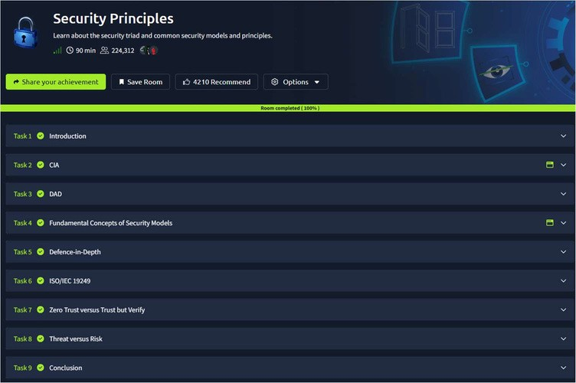
TASK 1 - Introduction
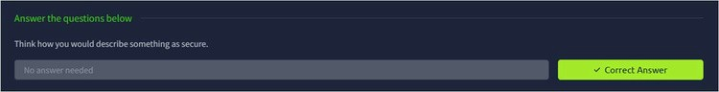

TASK 2 - CIA
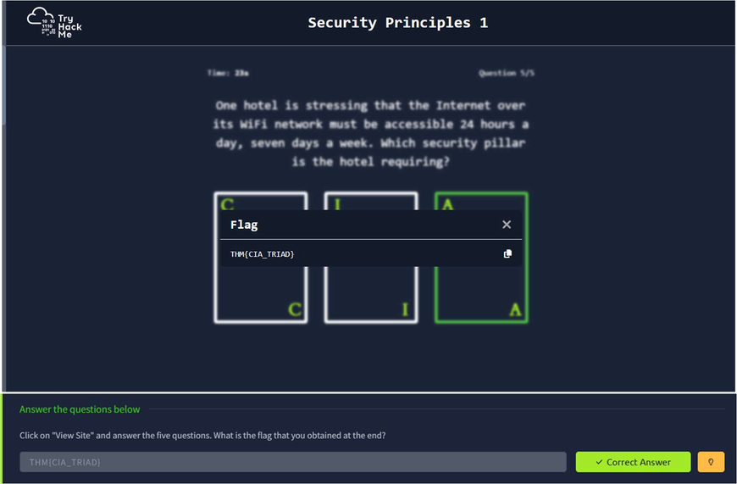
TASK 3 - DAD
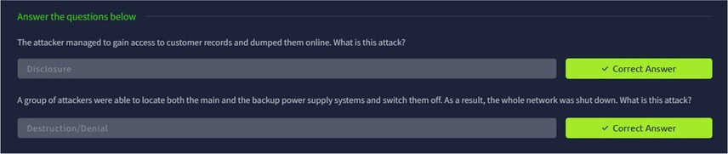
TASK 4 – Fundamental Concepts of Security Models
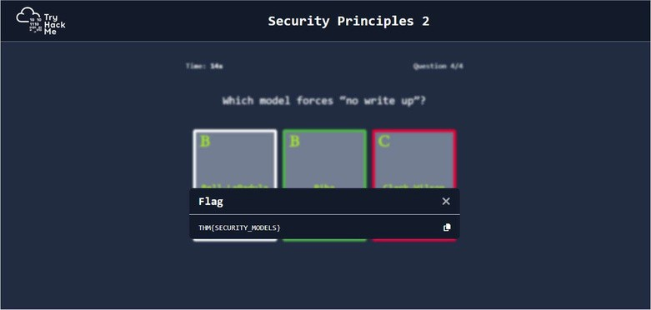
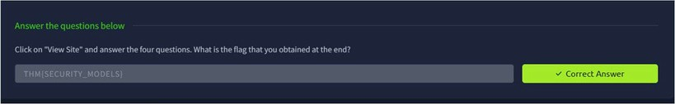
TASK 5 – Defence -in- depth
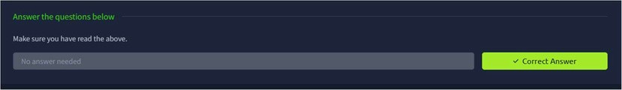
TASK 6 – ISO/IEC 19249
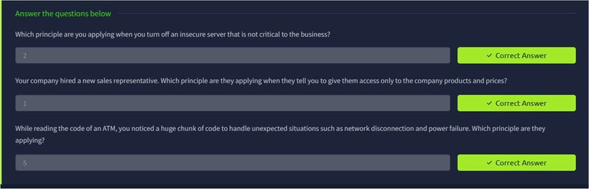
TASK 7 - Zero Trust vs Trust But Verify
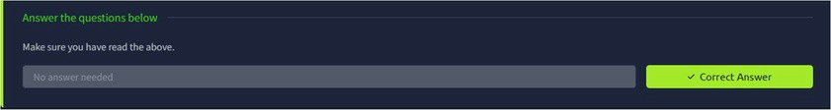
TASK 8 – Threat vs Risk
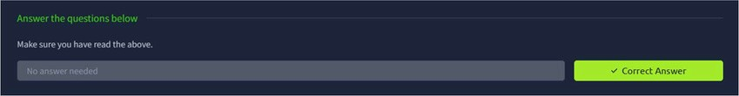
TASK 9 - Conclusion
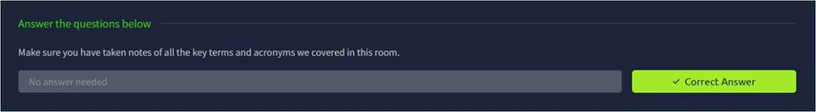
Result:
Thus the TryHackMe room “Security Models And Principles” was completed successfully.

